**Question 22: Do the respondents identify any discrepancies between these templates and instructions and the calculation of the requirements set out in the underlying regulation?**

Positions marked yellow the Template LR2 are not correctly mapped to the leverage reporting template C 47.00. In green is the proposal how the mapping should look like:

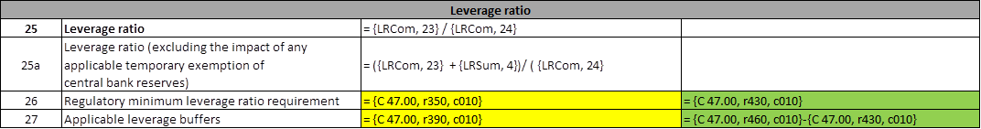

Template C 47.00 - LEVERAGE RATIO CALCULATION (LRCalc):

