Mapping of Egan-Jones Ratings Company’s credit assessments under the Standardised Approach

1. Executive summary
2. This report describes the mapping exercise carried out by the Joint Committee (JC) to determine the ‘mapping’[1] of the credit assessments of Egan-Jones Ratings Company (EJR).
3. The methodology applied to produce the mapping remains as specified in the Commission’s Implementing Regulation (EU) 2016/1799 (‘the Implementing Regulation’) laying down Implementing Technical Standards (ITS) with regard to the mapping of credit assessments of External Credit Assessment Institutions (ECAIs) for credit risk in accordance with Articles 136(1) and (3) of the Regulation (EU) No 575/2013 of the European Parliament and the Council (‘the CRR’). This Implementing Regulation employs a combination of the provisions laid down in Article 136(2) of CRR.
4. The mapping neither constitutes the one which the European Securities and MarketsAuthority (ESMA) shall report on in accordance with Article 21(4b) of Regulation (EC) No 1060/2009 (the ‘CRA Regulation’) with the objective of allowing investors to easily compare all credit ratings that exist with regard to a specific rated entity[2] nor should be understood as a comparison of the rating methodologies of EJR with those of other ECAIs. This mapping should however be interpreted as the correspondence of the rating categories of EJR with a regulatory scale which has been defined for prudential purposes. This implies that an appropriate degree of prudence may have been applied wherever not sufficient evidence has been found with regard to the degree of risk underlying the credit assessments.
5. As described in Recital 12 of the Implementing Regulation, it is necessary to avoid causing undue material disadvantage on those ECAIs which, due to their more recent entrance in the market, present limited quantitative information, with the view to balancing prudential with market concerns. Therefore, the relevance of quantitative factors for deriving the mapping should be relaxed. This allows ECAIs which present limited quantitative information to enter the market and increases competition. Updates to the mapping should be made wherever this becomes necessary to reflect additional quantitative information collected after the entry into force of the revised draft ITS.
6. The resulting mapping has been specified in Annex III of the revised draft ITS on the mapping of ECAIs’ credit assessments under Article 136(1) and (3) of the CRR. Figure 1 below shows the result for the main rating scale of EJR, the Long-Term Credit Rating Scale.

Figure 1: Mapping of EJR’s Long-Term Credit Rating Scale

|  |  |
| --- | --- |
| **Credit assessment** | **Credit quality step** |
| **AAA** | **1** |
| **AA** | **1** |
| **A** | **2** |
| **BBB** | **3** |
| **BB** | **4** |
| **B** | **5** |
| **CCC** | **6** |
| **CC** | **6** |
| **C** | **6** |
| **D** | **6** |

1. Introduction
2. This report describes the exercise carried out by the JC to determine the ‘mapping’ of the credit assessments of EJR.
3. EJR is a credit rating agency that has been certified with ESMA on 12 December 2014 and therefore meets the conditions to be an eligible ECAI[3].
4. The methodology applied to produce the mapping remains as specified in the Implementing Regulation, which employs a combination of the provisions laid down in Article 136(2) of the CRR, including quantitative and qualitative factors. The quantitative information reflects the statistics on the rating activity and the rating performance of ECAIs established by ESMA in its Central Repository (CEREP)[4], [5]. The qualitative information was collected bilaterally from EJR.
5. The following sections describe the rationale underlying the mapping exercise carried out by the JC to determine the mappings. Section 3 describes the rating scales of EJR for the purpose of the mapping. Section 4 contains the methodology applied to derive the mapping of the EJR’s main rating scale, whereas Sections 5 refers to the mapping of the remaining rating scale. The mapping tables are shown in Appendix 4 of this document.
6. EJR credit ratings and rating scales
7. EJR produces a variety of credit ratings; Column 2 of Figure 2 in Appendix 1 shows the relevant credit ratings that may be used by institutions for the calculation of risk weights under the Standardised Approach (SA)[6]:

* **Long-term issuer rating**: it is a forward-looking opinion about an obligor's overall creditworthiness. This opinion focuses on the likelihood of payment-capacity of the obligor to meet its financial commitment on an obligation in accordance with the terms of the obligation. It does not apply to any specific financial obligation, as it does not take into account the nature of and provisions of the obligation, its standing in bankruptcy or liquidation, statutory preferences, or the legality and enforceability of the obligation.
* **Long-term obligation rating:** it is defined as long-term ratings assigned to long-term financial obligations with an original maturity of one year or more. This opinion focuses on the likelihood of the full amount of both principal and interest to be paid timely.
* **Short-term issuer rating:** it is defined as the long-term obligation ratings described above, with the only difference that they refer to obligations with an original maturity of 12 months or less.
* **Short-term obligation rating:** it is defined as the long-term obligation ratings described above, with the only difference that they refer to obligations with an original maturity of 12 months or less.

1. EJR assigns these credit ratings to different rating scales, as illustrated in column 3 of Figure 2 in Appendix 1. Therefore, a specific mapping has been prepared for the following rating scales:

* **Long-term credit rating scale:** the specification of this rating scale is described in Figure 3 of Appendix 1.
* **Short-term credit rating scale:** the specification of this rating scale is described in Figure 4 of Appendix 1.

1. The mapping of the long-term credit rating scale is explained in Section 4 and it has been derived in accordance with the quantitative factors, qualitative factors and benchmarks specified in the ITS.
2. The mapping of the short-term credit rating scale is explained in Section 5 and it has been indirectly derived from the mapping of the long-term credit rating scale and the internal relationship established by EJR between these two scales, as specified in Article 13 ITS. This internal relationship is shown in Figure 5 of Appendix 1
3. Mapping of EJR’s long-term credit rating scale
4. The mapping of the long-term credit rating scale has consisted of two differentiated stages where the quantitative and qualitative factors were considered. In addition, the benchmarks specified in Article 136(2) CRR have been taken into account.
5. In the first stage, the quantitative factors referred to in Article 1 of the Implementing Regulation have been taken into account to differentiate between the levels of risk of each rating category:

* *The long-run default rate*of a rating category has been used to arrive at an initial mapping proposal by comparing its value with the benchmark specified in point (a) of Article 14 of the Implementing Regulation.
* *The* *short-run default rate* of the applicable rating categories has been compared with the benchmarks specified in point (b) of Article 14 of the Implementing Regulation, which represent the maximum expected deviation of a default rate from its long-term value within a CQS.

1. In a second stage, the qualitative factors proposed in Article 7 of the Implementing Regulation have been considered to challenge the initial mapping produced in the previous stage, especially in those ratings categories where less default data has been available.
   1. Initial mapping based on the quantitative factors
      1. Calculation of the short-run and long-run default rates
2. The short run and long run default rates of each rating category have been calculated with the pools of items rated from 1 January 2008 to 31 December 2015, based on the information contained in CEREP and taking into consideration information collected bilaterally from EJR related to private ratings[7]. The following aspects should be highlighted:

* For AAA, AA, A, as well as CCC-C rating categories, the number of credit ratings cannot be considered to be sufficient for the calculation of the short-run and long-run default rates specified in Articles 3 to 5 of the Implementing Regulation; therefore the allocation of the CQS has been made in accordance with Article 6 of the Implementing Regulation, as shown in Figure 14 of Appendix 3.
* For D rating category, no calculation of default rate has been made since it already reflects a ‘default’ situation.

1. For the remaining rating categories, the number of credit ratings can be considered to be sufficient and therefore the calculation has followed the rules established in Articles 3 to 5 of the Implementing Regulation. The result of the calculation of the short-run default rates for each rating category is shown in Figures 6 to Figure 8 of Appendix 3. Withdrawn ratings have been weighted by 50% as indicated in Article 4(3) of the Implementing Regulation.
2. The default definition applied by EJR, described in Appendix 2, should be taken into consideration for the calculation of default rates. According to an estimate provided by EGJ the share of bankruptcy-related events exceeds 90%. Following article 8 of the Implementing Regulation the quantitative factors are to be adjusted accordingly.
3. Regarding the long-run default rate, article 5(2) of the Implementing Regulation specifies that the long-run default rate shall be calculated as the weighted average of at least the most recent 20 short-run default rates calculated according to article 4(1). Where less than 20 short-run default rates are available, as it is the case of EJR, the remaining short-run default rates shall be estimated to span the 20 short-run default rates. The estimate has been calculated based on the value of 2008H1. Alternative estimations have been performed, which show the estimates are robust with respect to the benchmarks specified in article 14(a) of the Implementing Regulation.
   * 1. Mapping proposal based on the long-run default rate
4. In the case of rating categories AAA, AA, A and CCC-C, where the number of credit ratings cannot be considered sufficient for the calculation of the long-run default rate, Article 6 of the Implementing Regulation is applied. The result, as shown in Figure 14 of Appendix 3, confirms that the CQS assigned is the one the equivalent international rating category. The result holds regardless of the data cohort chosen. Further, following article 8 of the Implementing Regulation the quantitative factors are to be adjusted by the definition of default. According to an estimate provided by EGJ the share of bankruptcy-related events exceeds 90%. The CQS allocation holds when the number of defaults is doubled to impose a stricter definition of default, see figure 15 of Appendix 3.
5. Regarding rating categories BBB, BB and B the default rates are calculated in accordance to Articles 3 to 5 of the Implementing Regulation. Following article 8 of the Implementing Regulation the quantitative factors are to be adjusted accordingly, as shown in figures 9 and 10 of Appendix 3. Based on the comparison between the adjusted long-run default rates and the long-run default rate benchmarks established in point (a) of Article 14 of the ITS, the initial mapping allocation has been made as illustrated in Figure 16 of Appendix 4.
   * 1. Reviewed mapping based on the short run default rates
6. As shown in Figures 11 to Figure 13 in Appendix 3, the short run default rates of rating categories BBB, BB and B have been compared with the short run default rate benchmark values established in point (b) of Article 14 of the Implementing Regulation. The short-run default rates are adjusted by the default definition, as per Article 8 of the Implementing Regulation.
7. The objective is to assess, for each rating category, whether the short-run default rates have deviated from their corresponding benchmark values and whether any observed deviation has been caused by a weakening of the assessment standards. Therefore short run default rates experienced within a rating category have been compared with the short run benchmarks “monitoring” and “trigger” levels specified in Article 14(b) of the Implementing Regulation. To perform this analysis confidence intervals for the short run default rates have been calculated.
8. The result of this comparison can be found in the third column of Figure 16 in Appendix 4:

* BBB: the short-run default rate does not breach any of the benchmarks, although the upper bound of the confidence interval reaches the monitoring and trigger level in 2008H2. As it only affects one observation period, the mapping based on the long-run default rate is confirmed at this stage.
* BB: the short-run default rate does not breach any benchmarks, even taking into account the confidence interval. The mapping based on the long-run default rate is confirmed at this stage.
* B: the short-run default rate breaches the monitoring and trigger benchmarks in 2008H1. As it only affects one observation period, the long-run default rate is confirmed at this stage.
  1. Final mapping after review of the qualitative factors

1. The qualitative factors specified in Article 7 of the ITS have been used to challenge the mapping proposed by the default rates calculation. Qualitative factors acquire more importance in the rating categories where quantitative evidence is not sufficient to test the default behavior[8].
2. The **definition of default** applied by EJR and used for the calculation of the quantitative factors has been analysed:

* The types of default considered by EJR are shown in Appendix 2 and it is consistent with letters (a), (b) and (c) of the benchmark definition.
* The information provided by EJR shows that the share of bankruptcy-related events exceeds 90%, based on the distribution of defaults recorded in the three years to the beginning of 2017, which is expected by EJR to be representative. Following Article 8 of the Implementing Regulation, an adjustment was made to default rates based on this factor, which yielded CQS in line with the international rating scale, reinforcing the mapping.

1. The **meaning and relative position** of the credit assessments are aligned with the initial mapping proposals resulting from the quantitative factors.
2. Regarding the **time horizon** reflected by the rating category, EJR’s rating methodology focuses on a horizon of 3 years for the long-term credit rating. The stability of the rated items cannot be adequately assessed given the limited data. No specific adjustment has been proposed based on this factor.
3. Following Article 12 of the Implementing Regulation, the **estimate provided by the ECAI of the long-run default rate** should be taken into consideration, as long as it has been adequately justified. The estimate is conditioned by limited data history. Therefore no specific adjustment has been proposed based on this factor.
4. Finally, it should be highlighted the use of the long run default rate benchmark associated with the equivalent category in the international rating scale as the **estimate of the long run default rate** for the calculation of the quantitative factor of rating categories under Article 6 of the ITS.
5. Mapping of EJR short-term credit rating scale
6. EJR also produces short-term issuer and obligation ratings (see Figure 2 in Appendix 1). Given that the default information referred to these rating categories cannot be comparable with the 3-year time horizon that characterises the benchmarks established in the Implementing Regulation, the internal relationship established by EJR between these two rating scales (described in Figure 5 of Appendix 1) has been used to derive the mapping of the short-term credit rating scale. This is in line with Article 13 of the Implementing Regulation and should ensure the consistency of the mappings proposed for EJR.
7. More specifically, as each short-term rating category can be associated with a range of long-term rating categories, the CQS assigned to each short-term rating category has been determined based on the most frequent CQS assigned to the related long-term rating categories. In case of draw, the most conservative CQS has been considered. According to article 140(1) CRR, short-term credit assessments may only be used for short-term asset and off-balance sheet items constituting exposures to institutions and corporates. Following article 131 CRR, exposures to institutions and corporates with a short-term assignment are assigned a 150% risk weight if they are allocated to CQS 4, 5 or 6. Therefore if the most frequent step associated to the short-term scale is identified with CQS 5 or 6, then the allocation is made to CQS 4.
8. The result is shown in Figure 17 of Appendix 4:

* **A-1+:** this rating category indicates the obligor's capacity to meet its financial commitment on these obligations is extremely strong. It is internally mapped to the long-term categories AAA and AA, which are mapped to CQS 1. Therefore, CQS 1 is the proposed mapping.
* **A-1**: this rating category indicates the obligor's capacity to meet its financial commitment on these obligations is strong. It is internally mapped to the long-term category A, which is mapped to CQS 2. Therefore, CQS 2 is the proposed mapping.
* **A-2:** this rating category indicates is somewhat more susceptible to the adverse effects of changes in circumstances and economic conditions than obligations in higher rating categories. However, the obligor's capacity to meet its financial commitment on the obligation is satisfactory. In this case, following the internal mapping provided by the ECAI, the allocation could fall under CQS 2 or CQS 3. The most conservative CQS has been considered. Therefore, CQS 3 is the proposed mapping.
* **A-3:** this rating category exhibits adequate protection parameters. However, adverse economic conditions or changing circumstances are more likely to lead to a weakened capacity of the obligor to meet its financial commitment on the obligation. It is internally mapped to the long-term category BBB, which are mapped to CQS 3. Therefore, CQS 3 is the proposed mapping.
* **B:** this rating category is regarded as having significant speculative characteristics. The obligor currently has the capacity to meet its financial commitment on the obligation; however, it faces major ongoing uncertainties which could lead to the obligor's inadequate capacity to meet its financial commitment on the obligation. It is internally mapped to the long-term categories BB and B, which are respectively mapped to CQS 4 and CQS5. However, as the risk weights assigned to CQS 4 to 6 are all equal to 150% according to Article 131 CRR, the mapping proposed for the B category is CQS 4, that is also better in line with the meaning of this category.
* **C:** is currently vulnerable to non-payment and is dependent upon favorable business, financial, and economic conditions for the obligor to meet its financial commitment on the obligation. It is internally mapped to the long-term categories CCC, CC and C, which are mapped to CQS 6. Since the risk weights assigned to CQS 4 to 6 are all equal to 150% according to Article 131 CRR, the mapping proposed for the D rating category is CQS 4.
* **D.** This rating category is in payment default. The 'D' rating category is used when payments on an obligation are not made on the date due even if the applicable grace period has not expired, unless Egan-Jones's believes that such payments will be made during such grace period. The 'D' rating also will be used upon the filing of a bankruptcy petition or the taking of a similar action if payments on an obligation are jeopardized. indicates payment default. Therefore it is consistent with CQS 6. In addition, it is internally mapped to long-term categories D, which is mapped to CQS 6. Since the risk weights assigned to CQS 4 to 6 are all equal to 150% according to Article 131 CRR, the mapping proposed for the D rating category is CQS 4.

Appendix 1: Credit ratings and rating scales

Figure 2: Relevant credit ratings and rating scales

|  |  |  |
| --- | --- | --- |
| SA exposure classes | Name of credit rating | Credit rating scale |
| **Long-term ratings** |  |  |
| Central governments or central banks | Long-term issuer ratings | Long-term credit rating scale |
| Long-term obligation ratings |
| Corporates | Long-term issuer ratings | Long-term credit rating scale |
| Long-term obligation ratings |
| Institutions | Long-term issuer ratings | Long-term credit rating scale |
| Long-term obligation ratings |
| **Short-term ratings** |  |  |
| Corporates | Short-term issuer ratings | Short -term credit rating scale |
| Short-term obligation ratings |
| Institutions | Short -term issuer ratings | Short -term credit rating scale |
| Short -term obligation ratings |

Source: EJR.

Figure 3: EJR long-term credit rating scale

|  |  |
| --- | --- |
| Credit assessment | Meaning of the credit assessment |
| AAA | An obligation rated AAA has the highest rating assigned by EJR. The obligor's capacity to meet its financial commitment on the obligation is extremely strong. |
| AA | An obligation rated AA differs from the highest-rated obligations only to a small degree. The obligor's capacity to meet its financial commitment on the obligation is very strong. |
| A | An obligation rated A is somewhat more susceptible to the adverse effects of changes in circumstances and economic conditions than obligations in higher-rated categories. However, the obligor's capacity to meet its financial commitment on the obligation is still strong. |
| BBB | An obligation rated BBB exhibits adequate protection parameters. However, adverse economic conditions or changing circumstances are more likely to lead to a weakened capacity of the obligor to meet its financial commitment on the obligation. |
| BB | An obligation rated BB is less vulnerable to non-payment than other speculative issues. However, it faces major ongoing uncertainties or exposure to adverse business, financial, or economic conditions which could lead to the obligor's inadequate capacity to meet its financial commitment on the obligation. |
| B | An obligation rated B is more vulnerable to non-payment than obligations rated 'BB', but the obligor currently has the capacity to meet its financial commitment on the obligation. Adverse business financial or economic conditions will likely impair the obligor's capacity or willingness to meet its financial commitment on the obligation. |
| CCC | An obligation rated CCC is currently vulnerable to non-payment, and is dependent upon favourable business, financial, and economic conditions for the obligor to meet its financial commitment on the obligation. In the event of adverse business, financial or economic conditions, the obligor is not likely to have the capacity to meet its financial commitment on the obligation. |
| CC | An obligation rated CC is currently highly vulnerable to non-payment. |
| C | A subordinated debt or preferred stock obligation rated C is currently highly vulnerable to non-payment. It may be used to cover a situation where a bankruptcy petition has been filed or similar action taken, but payments on this obligation are being continued. It will also be assigned to a preferred stock issue in arrears on dividends or sinking fund payments, but that is currently paying. |
| D | An obligation rated D is in payment default. The payments on an obligation are not made on the date due even if the applicable grace period has not expired, unless EJR believes that such payments will be made during such grace period. The credit assessment also will be used upon the filing of a bankruptcy petition or the taking of a similar action if payments on an obligation are jeopardized. |

Source: EJR.

Figure 4: EJR short--term credit rating scale

|  |  |
| --- | --- |
| Credit assessment | Meaning of the credit assessment |
| A-1 | The obligor's capacity to meet its financial commitment on the obligation is strong. Within this category, certain obligations are designated with a plus sign (+). This indicates that the obligor's capacity to meet its financial commitment on these obligations is extremely strong. |
| A-2 | Short-term obligation somewhat more susceptible to the adverse effects of changes in circumstances and economic conditions than obligations in higher rating categories. However, the obligor's capacity to meet its financial commitment on the obligation is satisfactory. |
| A-3 | Short-term obligation that exhibits adequate protection parameters. However, adverse economic conditions or changing circumstances are more likely to lead to a weakened capacity of the obligor to meet its financial commitment on the obligation. |
| B | Short-term obligation having significant speculative characteristics. The obligor currently has the capacity to meet its financial commitment on the obligation; however, it faces major ongoing uncertainties which could lead to the obligor's inadequate capacity to meet its financial commitment on the obligation. |
| C | Short-term obligation that is currently vulnerable to nonpayment and is dependent upon favourable business, financial and economic conditions for the obligor to meet its financial commitment on the obligation. |
| D | Short-term obligation in default. It is used when payments on an obligation are not made on the date due even if the applicable grace period has not expired, unless EJR believes that such payments will be made during such grace period. The 'D' rating is also used upon the filing of a bankruptcy petition or the taking of a similar action if payments on an obligation are jeopardized. |

Source: EJR.Figure 5: Internal relationship between EJR’ long term and short-term credit rating scale

|  |  |
| --- | --- |
| **Long-term credit**  **rating scale** | **Short-term credit**  **rating scale** |
| AAA | A-1+ |
| AA+ |
| AA |
| AA- |
| A+ | A-1 |
| A |
| A- | A-2 |
| BBB+ |
| BBB | A-3 |
| BBB- |
| BB+ | B |
| BB |
| BB- |
| B+ |
| B |
| B- |
| CCC+ | C |
| CCC |
| CCC- |
| CC |
| C |
| D | D |

Source: EJR.

Appendix 2: Definition of default

Payments on an obligation are not made on the date due, even if the applicable grace period has not expired.

Source: EJR

Appendix 3: Default rates of each rating category

Figure 6: Number of rated items, with relevant weights[9]

|  |  |  |  |  |  |  |  |  |  |
| --- | --- | --- | --- | --- | --- | --- | --- | --- | --- |
| **Date** | **AAA** | **AA** | **A** | **BBB** | **BB** | **B** | **CCC** | **CC** | **C** |
| 01/01/2008 | 0.0 | 34.0 | 211.0 | 335.5 | 230.5 | 121.0 | 13.5 | 12.0 | 6.0 |
| 01/07/2008 | 0.0 | 33.5 | 207.5 | 343.0 | 215.5 | 119.5 | 23.5 | 21.5 | 13.5 |
| 01/01/2009 | 0.0 | 25.0 | 184.5 | 325.0 | 221.0 | 137.5 | 24.5 | 23.0 | 25.5 |
| 01/07/2009 | 1.0 | 18.0 | 164.5 | 285.5 | 206.5 | 117.5 | 36.0 | 26.0 | 18.5 |
| 01/01/2010 | 1.0 | 23.0 | 179.0 | 288.0 | 201.0 | 131.0 | 34.0 | 17.5 | 15.5 |
| 01/07/2010 | 2.0 | 30.5 | 196.5 | 288.5 | 185.5 | 124.5 | 24.0 | 7.5 | 4.0 |
| 01/01/2011 | 1.0 | 41.5 | 217.0 | 289.0 | 185.0 | 115.0 | 18.0 | 7.0 | 4.0 |
| 01/07/2011 | 0.0 | 52.5 | 235.0 | 307.0 | 183.0 | 115.0 | 19.5 | 6.0 | 5.0 |
| 01/01/2012 | 0.0 | 58.5 | 244.0 | 314.5 | 190.0 | 110.0 | 28.0 | 8.0 | 4.0 |
| 01/07/2012 | 0.0 | 60.0 | 251.0 | 328.0 | 194.0 | 121.0 | 21.5 | 10.0 | 5.0 |
| 01/01/2013 | 0.0 | 56.0 | 242.0 | 333.0 | 205.5 | 133.5 | 28.5 | 10.0 | 3.5 |

Source: JC calculations based on CEREP.

Figure 7: Number of defaulted rated items

|  |  |  |  |  |  |  |  |  |  |
| --- | --- | --- | --- | --- | --- | --- | --- | --- | --- |
| **Date** | **AAA** | **AA** | **A** | **BBB** | **BB** | **B** | **CCC** | **CC** | **C** |
| 01/01/2008 | 0 | 0 | 3 | 2 | 8 | 22 | 6 | 4 | 4 |
| 01/07/2008 | 0 | 0 | 0 | 3 | 7 | 12 | 9 | 9 | 7 |
| 01/01/2009 | 0 | 0 | 0 | 0 | 1 | 9 | 5 | 4 | 12 |
| 01/07/2009 | 0 | 0 | 0 | 0 | 0 | 3 | 3 | 1 | 0 |
| 01/01/2010 | 0 | 0 | 0 | 0 | 0 | 3 | 3 | 1 | 0 |
| 01/07/2010 | 0 | 0 | 0 | 0 | 0 | 4 | 3 | 0 | 0 |
| 01/01/2011 | 0 | 0 | 0 | 0 | 1 | 4 | 1 | 0 | 0 |
| 01/07/2011 | 0 | 0 | 0 | 0 | 1 | 3 | 1 | 0 | 1 |
| 01/01/2012 | 0 | 0 | 0 | 1 | 1 | 3 | 1 | 1 | 0 |
| 01/07/2012 | 0 | 0 | 0 | 0 | 1 | 5 | 2 | 1 | 0 |
| 01/01/2013 | 0 | 0 | 0 | 0 | 0 | 5 | 2 | 1 | 0 |

Source: JC calculations based on CEREP.

Figure 8: Short-run observed default rates

|  |  |  |  |  |  |  |  |  |  |
| --- | --- | --- | --- | --- | --- | --- | --- | --- | --- |
| **Date** | **AAA** | **AA** | **A** | **BBB** | **BB** | **B** | **CCC** | **CC** | **C** |
| 01/01/2008 | n.a | n.a | n.a | 0.60 | 3.47 | 18.18 | n.a | n.a | n.a |
| 01/07/2008 | n.a | n.a | n.a | 0.87 | 3.25 | 10.04 | n.a | n.a | n.a |
| 01/01/2009 | n.a | n.a | n.a | 0.00 | 0.45 | 6.55 | n.a | n.a | n.a |
| 01/07/2009 | n.a | n.a | n.a | 0.00 | 0.00 | 2.55 | n.a | n.a | n.a |
| 01/01/2010 | n.a | n.a | n.a | 0.00 | 0.00 | 2.29 | n.a | n.a | n.a |
| 01/07/2010 | n.a | n.a | n.a | 0.00 | 0.00 | 3.21 | n.a | n.a | n.a |
| 01/01/2011 | n.a | n.a | n.a | 0.00 | 0.54 | 3.48 | n.a | n.a | n.a |
| 01/07/2011 | n.a | n.a | n.a | 0.00 | 0.55 | 2.61 | n.a | n.a | n.a |
| 01/01/2012 | n.a | n.a | n.a | 0.32 | 0.53 | 2.73 | n.a | n.a | n.a |
| 01/07/2012 | n.a | n.a | n.a | 0.00 | 0.52 | 4.13 | n.a | n.a | n.a |
| 01/01/2013 | n.a | n.a | n.a | 0.00 | 0.00 | 3.75 | n.a | n.a | n.a |

Source: JC calculations based on CEREP.

Figure 9: Short-run default rates, adjusted by the defintion of default

|  |  |  |  |  |  |  |  |  |  |
| --- | --- | --- | --- | --- | --- | --- | --- | --- | --- |
| **Date** | **AAA** | **AA** | **A** | **BBB** | **BB** | **B** | **CCC** | **CC** | **C** |
| 01/01/2008 | n.a | n.a | n.a | 1.16 | 6.70 | 35.11 | n.a | n.a | n.a |
| 01/07/2008 | n.a | n.a | n.a | 1.68 | 6.28 | 19.39 | n.a | n.a | n.a |
| 01/01/2009 | n.a | n.a | n.a | 0.00 | 0.87 | 12.65 | n.a | n.a | n.a |
| 01/07/2009 | n.a | n.a | n.a | 0.00 | 0.00 | 4.92 | n.a | n.a | n.a |
| 01/01/2010 | n.a | n.a | n.a | 0.00 | 0.00 | 4.42 | n.a | n.a | n.a |
| 01/07/2010 | n.a | n.a | n.a | 0.00 | 0.00 | 6.20 | n.a | n.a | n.a |
| 01/01/2011 | n.a | n.a | n.a | 0.00 | 1.04 | 6.72 | n.a | n.a | n.a |
| 01/07/2011 | n.a | n.a | n.a | 0.00 | 1.06 | 5.04 | n.a | n.a | n.a |
| 01/01/2012 | n.a | n.a | n.a | 0.62 | 1.02 | 5.27 | n.a | n.a | n.a |
| 01/07/2012 | n.a | n.a | n.a | 0.00 | 1.00 | 7.98 | n.a | n.a | n.a |
| 01/01/2013 | n.a | n.a | n.a | 0.00 | 0.00 | 7.24 | n.a | n.a | n.a |

Source: JC calculations based on CEREP.

Figure 10: Estimated long-run default rate, adjusted by the definiton of default

|  |  |  |  |  |  |  |  |  |  |
| --- | --- | --- | --- | --- | --- | --- | --- | --- | --- |
| **Date** | **AAA** | **AA** | **A** | **BBB** | **BB** | **B** | **CCC** | **CC** | **C** |
| 01/01/2008 | n.a | n.a | n.a | 0.72 | 4.16 | 21.60 | n.a | n.a | n.a |

Source: JC calculations based on CEREP.

Figure 11: Short-run and long-run observed default rates of BBB rating category

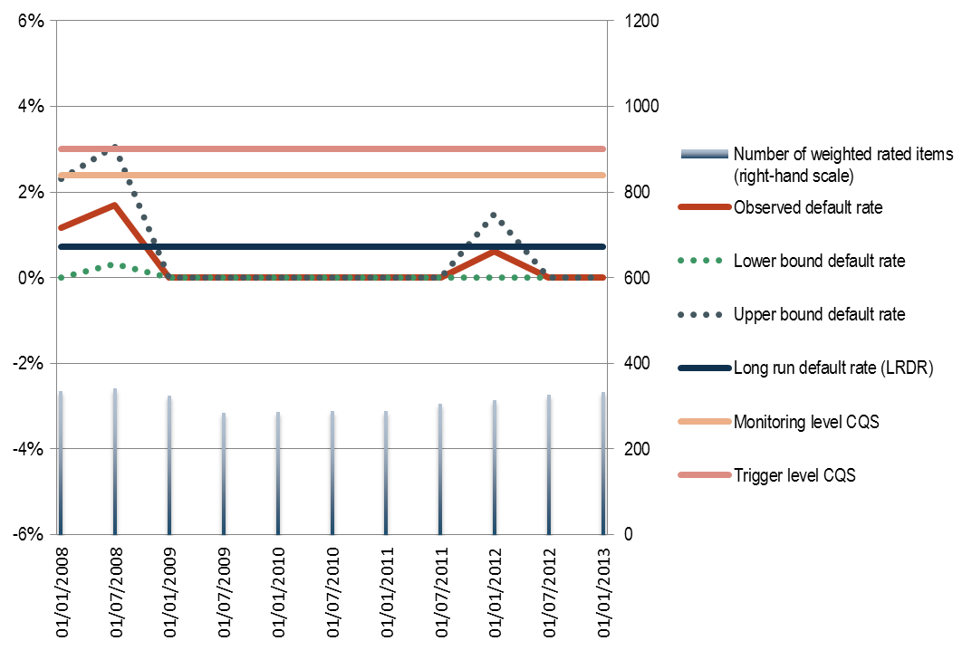

Source: JC calculations based on CEREP.

Figure 12: Short-run and long-run observed default rates of BB rating category

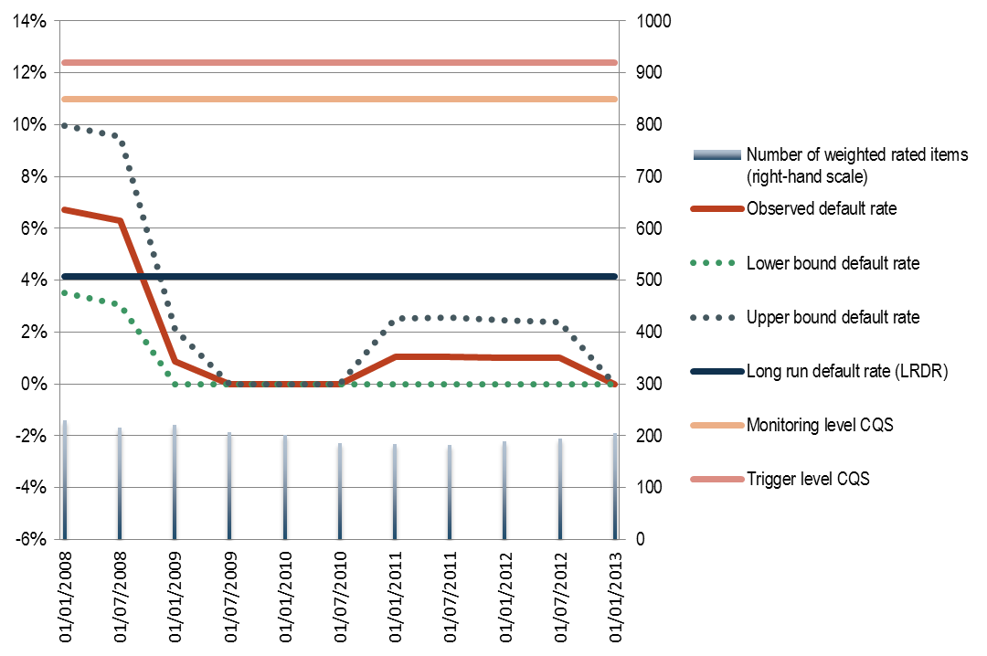

Source: JC calculations based on CEREP.

Figure 13: Short-run and long-run observed default rates of B rating category

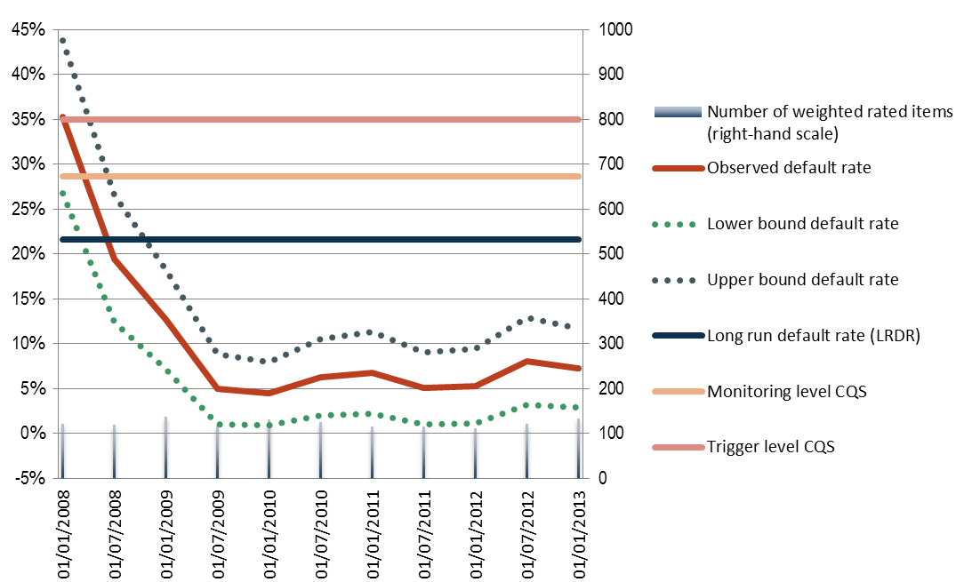

Source: JC calculations based on CEREP.

Figure 14: Mapping proposal for rating categories with a non-sufficient number of credit ratings

|  |  |  |  |
| --- | --- | --- | --- |
| **2008H1 – 2010H1** | **AAA-AA** | **A** | **CCC-C** |
| CQS of equivalent international rating category | CQS 1 | CQS 2 | CQS 6 |
| N. observed defaulted items | 0 | 3 | 68 |
| Minimum N. rated items required | 0 | 167 | n.a. |
| Observed N. rated items | 135.5 | 946.5 | 310.5 |
| **Mapping proposal** | **CQS1** | **CQS2** | **CQS6** |

|  |  |  |  |
| --- | --- | --- | --- |
| **2010H2 – 2013H1** | **AAA-AA** | **A** | **CCC-C** |
| CQS of equivalent international rating category | CQS 1 | CQS 2 | CQS 6 |
| N. observed defaulted items | 0 | 0 | 14 |
| Minimum N. rated items required | 0 | 0 | n.a. |
| Observed N. rated items | 302 | 1,385.5 | 213.5 |
| **Mapping proposal** | **CQS1** | **CQS2** | **CQS6** |

Source: JC calculations based on CEREP data

Figure 15: Mapping proposal for rating categories with a non-sufficient number of credit ratings, adjusted to reflect a stricter definition of default

|  |  |  |  |
| --- | --- | --- | --- |
| **2008H1 – 2010H1** | **AAA-AA** | **A** | **CCC-C** |
| CQS of equivalent international rating category | CQS 1 | CQS 2 | CQS 6 |
| N. observed defaulted items | 0 | 6 | 136 |
| Minimum N. rated items required | 0 | 699 | n.a. |
| Observed N. rated items | 135.5 | 946.5 | 310.5 |
| **Mapping proposal** | **CQS1** | **CQS2** | **CQS6** |

|  |  |  |  |
| --- | --- | --- | --- |
| **2010H2 – 2013H1** | **AAA-AA** | **A** | **CCC-C** |
| CQS of equivalent international rating category | CQS 1 | CQS 2 | CQS 6 |
| N. observed defaulted items | 0 | 0 | 28 |
| Minimum N. rated items required | 0 | 0 | n.a. |
| Observed N. rated items | 302 | 1,385.5 | 213.5 |
| **Mapping proposal** | **CQS1** | **CQS2** | **CQS6** |

Source: JC calculations based on CEREP data

Appendix 4: Mappings of each rating scale

Figure 16: Mapping of EJR’s long-term credit rating scale

|  |  |  |  |  |  |
| --- | --- | --- | --- | --- | --- |
| **Credit assessment** | **Initial mapping *based on quantitave factors*  (CQS)** | **Review based on SRDR (CQS)** |  | **Final review *based on qualitative factors* (CQS)** | **Main reason for the mapping** |
| **AAA** | 1 | 1 |  | 1 | The quantitative factors are representative of the final CQS. |
| **AA** | 1 | 1 |  | 1 | The quantitative factors representative of the final CQS. |
| **A** | 2 | 2 |  | 2 | The quantitative factors representative of the final CQS |
| **BBB** | 3 | 3 |  | 3 | The quantitative factors are representative of the final CQS. |
| **BB** | 4 | 4 |  | 4 | The quantitative factors are representative of the final CQS. |
| **B** | 5 | 5 |  | 5 | The quantitative factors are representative of the final CQS. |
| **CCC** | 6 | 6 |  | 6 | The quantitative factors are representative of the final CQS. |
| **CC** | 6 | 6 |  | 6 | The quantitative factors are representative of the final CQS. |
| **C** | 6 | 6 |  | 6 | The meaning and relative position of the rating category is representative of the final CQS |
| **D** | 6 | 6 |  | 6 | The meaning and relative position of the rating category is representative of the final CQS |

Figure 17: Mapping of EJR’s short-term credit rating scale

|  |  |  |  |  |
| --- | --- | --- | --- | --- |
| **Credit assessment** | **Range of CQS of corresponding to the long-term rating scale** |  | **Final review *based on qualitative factors* (CQS)** | **Main reason for the mapping** |
| **A-1+** | 1 |  | **1** | The final CQS has been determined based on the most frequent step associated with the corresponding global long-term credit rating category. |
| **A-1** | 2 |  | **2** | The final CQS has been determined based on the most frequent step associated with the corresponding global long-term credit rating category. |
| **A-2** | 2-3 |  | **3** | The final CQS has been determined based on the most frequent step associated with the corresponding global long-term credit rating category. |
| **A-3** | 3 |  | **3** | The final CQS has been determined based on the most frequent step associated with the corresponding global long-term credit rating category. |
| **B** | 4-5 |  | **4** | The final CQS has been determined based on the most frequent step associated with the corresponding global long-term credit rating category. The risk weights assigned to CQS 4 to 6 are all 150%, therefore CQS 4. |
| **C** | 6 |  | **4** | The final CQS has been determined based on the most frequent step associated with the corresponding global long-term credit rating category. The risk weights assigned to CQS 4 to 6 are all 150%, therefore CQS 4. |
| **D** | 6 |  | **4** | The final CQS has been determined based on the most frequent step associated with the corresponding global long-term credit rating category. The risk weights assigned to CQS 4 to 6 are all 150%, therefore CQS 4. |

1. According to Article 136(1), the ‘mapping’ is the correspondence between the credit assessments of and ECAI and the Credit Quality Steps (CQS) set out in Regulation (EU) No 575/2013 (Capital Requirements Regulation – CRR).
2. In this regard please see <https://www.esma.europa.eu/sites/default/files/library/esma_2015-1473_report_on_the_possibility_of_establishing_one_or_more_mapping.pdf>.
3. The mapping does not contain any assessment of the registration process of EJR carried out by ESMA.
4. http://cerep.esma.europa.eu/cerep-web/ These statistics are computed from individual rating information provided by registered or certified Credit Rating Agencies (CRAs) to ESMA, as required as per Article 11(2) of Regulation (EU) No 1060/2009 (CRA Regulation).
5. The last reporting period for which data are available in CEREP is the second semester of 2015.
6. As explained in recital 4 ITS, Article 4(1) CRA allows the use of the credit assessments for the determination of the risk-weighted exposure amounts as specified in Article 113(1) CRR as long as they meet the definition of credit rating in Article 3(1)(a) CRA.
7. Based on the qualitative information submitted by EJR, it was identified that solicited corporate long-term credit ratings submitted to ESMA refer to private credit ratings, which are out of the scope of this exercise and therefore have been manually excluded. ESMA was informed accordingly and EJR has resubmitted correct data to ESMA, which will be reflected in the next release of CEREP.
8. The default behavior of a rating category is considered to be properly tested if the quantitative factors for that rating category are calculated under Articles 3 – 5 ITS.
9. Withdrawn ratings have been weighted by 50% as indicated in Article 4(3) of the ITS.