User guide for Conversion file

Introduction

About the Conversion file

The conversion file aims to document the decisions taken in the context of the DPM Quality Review project, launched in 2023 with the purpose of increasing the quality of EBA glossary, semantically integrate its concepts and start using the new functionalities that DPM 2.0 offers. Up to now, 65% of EBA glossary has been reviewed and improved, encompassing liquidity templates glossary (reviewed in a first PoC) and the basic domains (Metrics, Main category, Base, Counterparties, Portfolios and Liquidity old domains).

In this context, the conversion file was developed with the purpose to:

- Document the final decisions and the conversion between all elements in the old glossary (Domains, dimensions, domain members and hierarchies) and its correlative/s new ones in the new glossary (Categories, properties, items, and subcategories).

- Communicate the new glossary to stakeholders, as it has been implemented in the modelling of all EBA reporting frameworks and serve as a reference to develop the modelling of release v 4.0, for information and feedback.

Contact point
For more information please contact: EBA.reporting@eba.europa.eu

- General instructions
The conversion file shows the correspondence between the elements from old glossary and new elements conforming the new glossary. The information about each element of the glossary (Categories, properties, items, and subcategories) is showed separately, having each of them a dedicated sheet.
- Categories
This sheet provides information about domains in the old glossary and their corresponding equivalent(s) categories in the new glossary.
The old domain name (Column A) and its corresponding old code (Column B), which form the old glossary, are displayed in the first two columns. On the right side, highlighted in blue, information about the corresponding new categories that will replace the old domain is shown (new glossary).
Under this part dedicated to the new glossary, in addition to the name of the category that will replace the old one (Column C), and its new code (Column D), you will find information on whether it is a newly created category or an already existing category (Column E).
Moreover, it is indicated whether it has been defined as a supercategory (Column F), and if so, the composition of the supercategory (Column G).
Lastly, information on whether it is an enumerated category or not is provided in Column H.

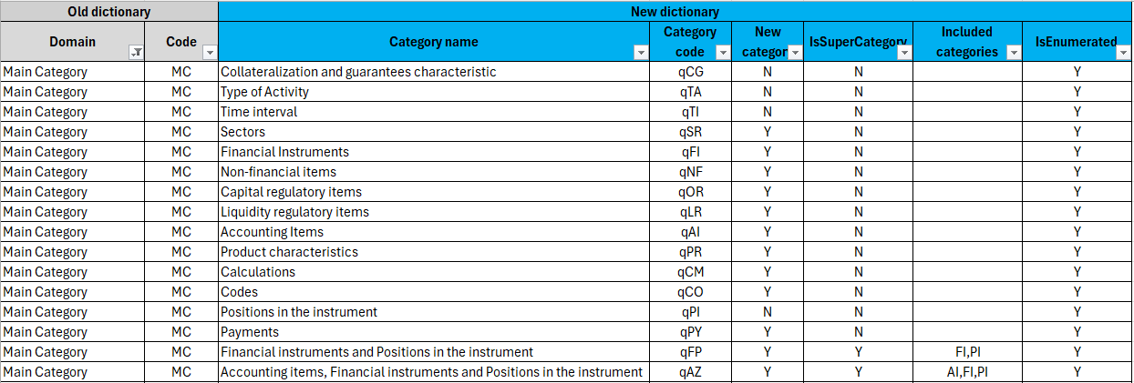

As an example, screenshot n1 illustrates the decision regarding the old domain Main category (MC), which has been divided into more specific categories, some of them new, some of them already existing. The old domain will be replaced then by the indicated categories in the new glossary. In other words, the old category has been removed, and the various items, properties, and subcategories in DPM 2.0 (dimensions, domain members and hierarchies in DPM 1.0), that were allocated under this old domain, have been reallocated to more suitable categories, newly created or already existing ones that will be kept in the new glossary (with a “q” in front of the old code, i.e, qTI).
For example, some elements that were allocated previously to MC domain, will be part now of the new category Financial instruments (qFI), because they are related to financial instruments. On the other hand, some other elements allocated in old MC domain that are related to time intervals, will be reallocated under the already existing Time interval (TI) domain, that will still be part of the new glossary, differentiating old from new with a letter “q” in front of old code (qTI).

- Properties
This sheet provides information about dimensions in the old glossary and their corresponding equivalent(s) properties in the new glossary.
The old dimension name (Column A), its corresponding old code (Column B), and the old domain to which they belonged (Column C) are displayed in the first three columns of the sheet (old glossary).
On the right side, Column D shows the type of conversion that has been applied. The different types of conversions applied are as follows:
- No changes
- To be removed
- “1:X”: If a 1:1 conversion has been applied, it implies a simple relabelling of the old dimension or a reallocation into a category different than the old domain to which it belong to. If a 1:X conversion has been applied, it means the old dimension has been split into X more specific or suitable properties, allocated under the same or different category/ies.
- New property added: as per the conversion decision for items, in some cases a new property was needed to provide a more specific context to a certain item. In these cases, a new property has been created.

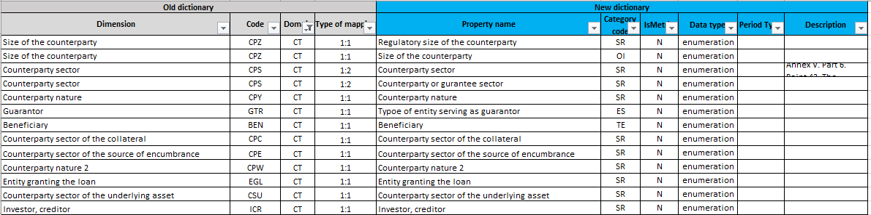
As an example, screenshot n2 shows that the old property “Counterparty sector” has been split into “Counterparty sector” and a broader property “Counterparty or guarantee sector” to accommodate cases where the sector is required not only for counterparties but also for guarantees.
Under the part dedicated to the new glossary, in addition to the name of the new property (Column E) and the category to which it belongs (Column F), you will find an indication of whether it is a metric (Column G), its data type (Column H), its period type (Column I), and, if necessary, a description (Column J).
It is important to note that under DPM 2.0, metrics are considered as properties (same as dimensions in DPM 1.0), with the main difference coming from the fact that the treatment for metrics apply only to quantitative properties. Therefore, this sheet also includes the conversion information for metrics (quantitative properties).
Please be aware that this sheet contains not only properties derived from the conversion of basic domain items but also properties from the proposed conversion for non-basic domains, which is still a work in progress, until the full revision of the glossary is completed.

- Items (1 to n)
This sheet provides information about domain members in the old glossary and their corresponding equivalent(s) items in the new glossary.
On the old glossary side, it shows information about the old domain member code (Column A), the member label (Column B), as well as information on whether the item was included in a dropdown list (to restring an enumerated property) under column C.
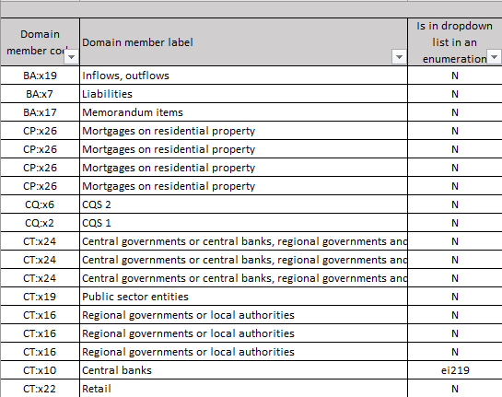
Following this information, it is showed the type of conversion that has been applied (column D), classified as follows:
- No changes
- To be removed
- 1:X conversion: If a 1:1 conversion has been applied, it implies a simple relabelling of the old item or its reallocation into a different category. If a 1:X conversion has been applied, it means the old item has been split into X more specific or suitable items. This means that wherever an old item was used in the modelling, the new modelling will be represented with new X items, replacing the old one.

As an example, screenshot n4 shows that the old domain members “QCCPs” and “Non-QCCPs” have been split into the new item “Central Counterparty” and, subsequently, into the new items “Qualified Central Clearing Counterparty” and “Non-Qualified Central Clearing Counterparty”. This means that wherever the old domain member CT:x81 was used in the modelling, now new item “Central counterparty” in new category qTE and new item “Non-Qualified Central Clearing Counterparty” in new category qOR will appear in the modelling, replacing the old domain member. The same would apply in the second case, but using new item “Qualified Central Clearing Counterparty” in new category qOR.
- Compound item: This a new DPM 2.0 feature that allow us, whenever it is necessary from a business perspective or for modelling reasons, to further explain the composition of an item.

For example, screenshot n5 shows the old domain member MC:x720 “STS securitisations”, that has been reallocated into the newly created category Financial instruments (qFI), has been considered necessary to be further explained due to business complexity of the concept. Accordingly, the new compound item “STS securitisation” in the new Financial Instruments (qFI) category, will be composed of the item “Securitisations” in Financial instruments (qFI) category and of the item “Meeting requirements to be considered simple, transparent and standardised (STS)” in the newly created category Capital regulatory items (OR).

- Aggregating item: We are using this concept to document those items that are simply aggregations of single items, and so they will be defined in a subcategory.

For example, screenshot n6 shows the mapping for old domain member PL:x10 “Trading and banking book”, which is an aggregation of both portfolios. In the new glossary it will be kept the same (under qPL), and it will be documented as an aggregating item, and as such a subcategory will be created to explain the hierarchy.
Additionally, under Column E, you will find further information about the type of conversion in the specific cases “1:X” and “Compound items”, indicating the number of items into which the old one is being split or the number of items within the compound item (e.g., 1:2, 1:3).
Where different conversions were decided for different templates, it has been indicated in Column F (conversion applicable to).
Under the part dedicated to the new glossary, you will find information about the corresponding new item(s) that will replace the old one, including the category they belong to (Column G), whether they are classified as compound items (Column H), the item name (Column I) and the property by default used in the modelling along with the item (Column J).
Note that subcategories will not be created in the glossary until the final revision of the glossary, except for those linked to enumerated properties and/or explaining the hierarchies for aggregating items. This is because we can’t ensure the consistency of the subcategories till all the glossary elements have been fully reviewed.
Finally, information about the reference in the regulation (document, articles, and description) is shown in Columns L, M, and N.

- Items (m to n)
Under this sheet you will find information about decisions that were taken considering a block of items at the same time, to be mapped into X new items. You will find on the right-side information about old item 1, 2, 3 and/or 4 (with an indication of the domain to which they belong to, the item code and label) that combined have been substituted by the new items 1,2, 3 and/or 4 that are indicated on the right side and highlighted in blue.
For example, screenshot n7 show that whenever we are modelling one cell with the combination of old domain member MC:x130 Equity instruments with old domain member CT:x35 Collective Investment Undertakings, we are converting it into a new combination, that will be the one used in the modelling, of new item CIU shares/units in newly created category Financial instruments (FI) and new item Collective Investment Undertakings in newly created category Sectors (SR).

